Training set analysis

1. Total number of training project：153
2. Total count number of training project (have warnings)：118
3. Project without warnings:
   1. ans
   2. b+tree
   3. babelstream
   4. bitonic
   5. cfd
   6. che
   7. clink
   8. cobahh
   9. crc64
   10. divergence
   11. dwt
   12. libor
   13. lid-driven-cavity
   14. lombscargle
   15. lud
   16. mandelbrot
   17. matrix-mul
   18. matrix-remote
   19. metropolis
   20. miniFE
   21. miniWeather
   22. minimap2
   23. minray
   24. mixbench
   25. Mkl-segmm
   26. Particle-diffusion
   27. Particlefilter
   28. Projectile
   29. randomAccess56
   30. Results
   31. Rsbench
   32. Scan2
   33. Secp256k1
   34. Shmembench
   35. Shuffle
   36. Sort
   37. Streamcluster
   38. Cu3
   39. Sw4lite
   40. traid
   41. Urng
   42. xsbench
4. Total number of warning: 788
5. The number of types of warnings: 15

Sort by warning type：

|  |  |  |
| --- | --- | --- |
|  | Warning type | numbers |
| 1 | 1000 | 9 |
| 2 | 1001 | 9 |
| 3 | 1003 | 154 |
| 4 | 1004 | 3 |
| 5 | 1007 | 3 |
| 6 | 1008 | 21 |
| 7 | 1009 | 2 |
| 8 | 1010 | 9 |
| 9 | 1011 | 20 |
| 10 | 1013 | 31 |
| 11 | 1017 | 2 |
| 12 | 1032 | 8 |
| 13 | 1039 | 37 |
| 14 | 1049 | 255 |
| 15 | 1065 | 225 |
|  | SUM | 788 |

Sort by warning number：

|  |  |  |
| --- | --- | --- |
|  | Warning type | numbers |
| 1 | 1049 | 255 |
| 2 | 1065 | 225 |
| 3 | 1003 | 154 |
| 4 | 1039 | 37 |
| 5 | 1013 | 31 |
| 6 | 1008 | 21 |
| 7 | 1011 | 20 |
| 8 | 1000 | 9 |
| 9 | 1001 | 9 |
| 10 | 1010 | 9 |
| 11 | 1032 | 8 |
| 12 | 1004 | 3 |
| 13 | 1007 | 3 |
| 14 | 1017 | 2 |
| 15 | 1009 | 2 |
|  | SUM | 788 |

1. Warning location and number:

Brief form：

|  |  |  |  |  |
| --- | --- | --- | --- | --- |
|  | Warning type | Occurrence numbers | Number of documents | Average |
| 1 | 1049 | 255 | 95 | 2.68 |
| 2 | 1065 | 225 | 49 | 4.59 |
| 3 | 1003 | 154 | 11 | 14 |
| 4 | 1039 | 37 | 11 | 3.36 |
| 5 | 1013 | 31 | 1 | 31 |
| 6 | 1008 | 21 | 7 | 3 |
| 7 | 1011 | 20 | 3 | 6.6 |
| 8 | 1000 | 9 | 5 | 1.8 |
| 9 | 1001 | 9 | 5 | 1.8 |
| 10 | 1010 | 9 | 7 | 1.28 |
| 11 | 1032 | 8 | 1 | 8 |
| 12 | 1004 | 3 | 1 | 3 |
| 13 | 1007 | 3 | 2 | 1.5 |
| 14 | 1017 | 2 | 1 | 2 |
| 15 | 1009 | 2 | 2 | 1 |

Detail form：

|  |  |  |  |  |  |
| --- | --- | --- | --- | --- | --- |
|  | Warning type | Occurrence numbers | Number of documents | Occurrence project | Average |
| 1 | 1049 | 255 | 95 | Myocyte [1]；  maxpool3d [1]；  Sph [4]；  inversek2j [1]；  Bn [1];  Popcount [5];  Dslash [1];  Knn [3];  Minimod [7];  Sosfil [1];  Radixsort [6];  Gd [3];  Sobol [1];  Bsw [2];  Gmm [2];  Extrema [2];  Laplace [2];  Nn [1];  Minisweep[4];  Asta [1];  Gaussian [2];  black-scholes [1];  Md [2];  Backprop [2];  Mdh [2];  Amgmk [1];  Present [1];  Geodesic [1];  Heat [3];  Pathfinder [1];  rtm8 [1];  Mt [2];  Dp [1];  Clenergy [1];  Snake [1];  page-rank [2];  atomicIntrinsics [1];  all-pairs-distance [2];  Thomas [1];  Deredundancy [13];  s3d [27];  Hybridsort [4];  Hmm [1];  Sssp [1];  easyWave [2];  Haccmk [1];  Srad [6];  hotspot3D [1];  Jaccard [5];  epistatis [1];  Boxfilter [2];  Fpc [2];  Multimaterial [5];  convolutionSeparable [2];  lid-driven-cavity [11];  heat2d [1];  Qtclustering [4];  Nw[2];  Nms [2];  Ss [2];  Kmeans [2];  Ldpc[4];  rng-wallace [1];  Floydwarshall [1];  Softmax [1];  compute-score [2];  Libor [2];  Particles [9];  Minibude [2];  Medianfilter [1];  Lulesh [14]  jenkins-hash [1]  Bfs [2]  recursiveGaussian [4]  Winograd [1]  Reduction [5]  murmurhash3 [1]  Lombscargle [1]  Sampling [2]  Nbody [1]  bezier-surface [1]  Qrg [2]  md5hash [1]  d2q9-bgk [1]  Filter [1]  Flame [3]  fdtd3d [1]  Simplemoc [1]  dct8x8 [2]  testSNAP [7]  bspline-vgh [1]  Affine [1]  Diamond [1]  iso2dfd [2]  chi2 [1] | 2.68 |
| 2 | 1065 | 225 | 49 | Bn [4];  Axhelm [7];  Knn [2];  Minimod [4];  Sosfil [4]  Radixsort [15]  Sobol [1]  Bsw [19]  Gmm [28]  Asta [5]  Transpose [2]  Mdh[4]  Clock [2]  Bsearch [1]  Pathfinder [3]  Scan [2]  Lanczos [2]  all-pairs-distance [2]  Deredundancy [1]  Sssp [6]  Srad [4]  Grep [1]  Reverse [1]  Boxfilter [1]  Fpc [4]  convolutionSeparable[2]  lid-driven-cavity [8]  dxtc1[5]  Nw [12]  Nms [1]  Ss [8]  Lud [6]  Ldpc [1]  Rgn-wallace[6]  Ced[3]  Compute-score[1]  Particles [9]  Minibude [1]  Medianfilter [1]  recursiveGaussian [1]  Sampling[1]  d2q9-bgk [1]  Vmc [2]  Filter [4]  Stencil [1]  fdtd3d [2]  Split [7]  Tridiagonal [17] | 4.59 |
| 3 | 1003 | 154 | 11 | inversek2j [1];  Gmm [51];  Quicksort [15];  Heat [2];  Memcpy [1];  s3d [37];  Ising [7];  Nms [8];  Aobench [4];  Vmc [23];  chi2 [5] | 14 |
| 4 | 1039 | 37 | 11 | Gd [4];  Minisweep [1];  Asta [5];  ccsd-trpdrv [4];  all-pairs-distance [1];  Sssp [12];  Jaccard [1];  Fpc [2];  randomAccess [1];  Reduction [5];  Filter [1] ; | 3.36 |
| 5 | 1013 | 31 | 1 | Tridiagonal [31]; | 31 |
| 6 | 1008 | 21 | 7 | Bn [4];  Clock [2];  ccsd-trpdrv [2];  Memcpy [4];  Hybridsort [6];  Aobench [2];  Simplemoc [1]; | 3 |
| 7 | 1011 | 20 | 3 | dxtc1[6];  Particles [8];  Tridiagonal [6]; | 6.6 |
| 8 | 1000 | 9 | 5 | inversek2j [1];  Heat [2];  Memcpy [1]; reduction [1];  chi2 [4] | 1.8 |
| 9 | 1001 | 9 | 5 | inversek2j [1];  Heat [2];  Memcpy [1]; reduction [1];  chi2 [4] | 1.8 |
| 10 | 1010 | 9 | 7 | Keccaktreehash [1];  Quicksort [2];  Clenergy [1];  Nms [2];  Aobench [1];  Reduction[1];  Flame[1] | 1.28 |
| 11 | 1032 | 8 | 1 | Vmc [8] | 8 |
| 12 | 1004 | 3 | 1 | dxtc1 [3] | 3 |
| 13 | 1007 | 3 | 2 | Sptrsv [2];  Vmc [1] | 1.5 |
| 14 | 1017 | 2 | 1 | Lombscargle [2] | 2 |
| 15 | 1009 | 2 | 2 | Clenergy [1];  Reduction [1] | 1 |

<10

<30

<50

>50

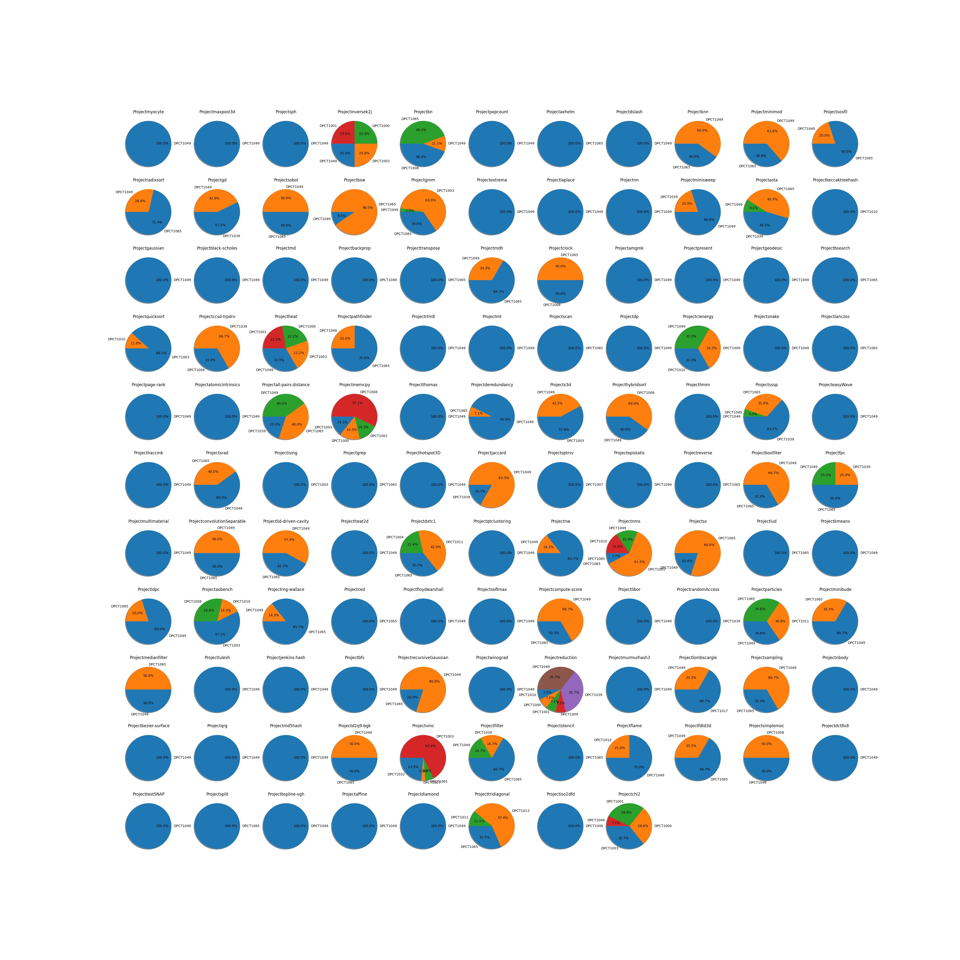

Top 2 graph analysis：

